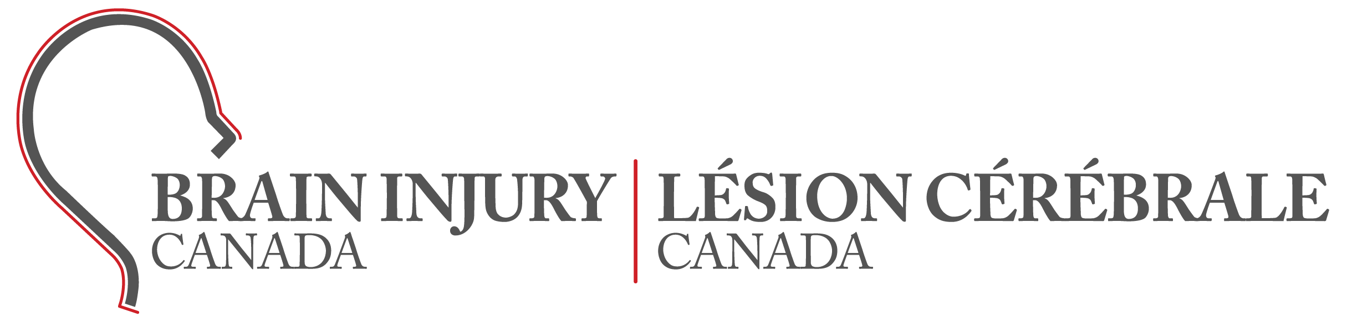
MEDIA RELEASE
FOR IMMEDIATE RELEASE
JUNE 1, 2023

Brain Injury Awareness Month & the chronic nature of traumatic brain injury

OTTAWA, ON - June is Brain Injury Awareness Month in Canada. There are 165,000 serious traumatic brain injuries (TBIs) per year. This means 452 Canadians suffer a moderate to severe traumatic brain injuries every day. This amounts to approximately one person every 3 minutes. This does not include concussions, non-traumatic brain injuries, military injuries, or unreported cases, which results in millions of Canadians impacted by brain injury.

Acquired brain injury is defined as damage to the brain that occurs after birth. Brain injuries can have a variety of causes and affect every aspect of a person’s life. Annual incidences of acquired brain injuries in Canada are:

- 30 times more common than breast cancer
- 44 times more common than spinal cord injuries
- 400 times more common than HIV/AIDS

The prevalence of brain injury is well-established. But awareness of brain injury in the general public remains low. Lack of awareness of brain injury contributes to both personal and systemic barriers that make daily living and community interactions challenging for the over 1.5 million Canadians with brain injury, their caregivers, and their families. And these are not short-term challenges – for the majority of individuals, the effects of brain injury are chronic and life-long. Yet there is little research on the long-term implications of brain injury, resulting in critical gaps in care for hundreds of thousands of Canadians.

This month, Brain Injury Canada is publishing a position paper on moderate to severe traumatic brain injury, its prevalence, and how classifying it as a chronic condition will help address the lack of recognition and understanding of TBI as a chronic health condition and ensure health systems have the data to allocate appropriate supports and resources over the life span. This position paper will be a valuable advocacy tool in the efforts to build awareness of brain injury and the need for supports.

Local brain injury associations deliver essential direct services and will have their own activities and events during Brain Injury Awareness Month. Please visit www.braininjurycanada.ca/abi-associations to find your local association and how you can support them.
For more information about brain injury, visit www.braininjurycanada.ca. Support this year’s Brain Injury Awareness Month campaign by following along on our social media, donating, and/or sharing the stories of people with brain injury.
###
For further media information contact:
Michelle McDonald
Chief Executive Officer
Tel: 613-762-1222
Email: mmcdonald@braininjurycanada.ca
www.braininjurycanada.ca

